USER INTERFACE DESIGN
EXPERIMENT 6: Simulate the Lifecycle Stages for UI Design Using the RAD Model and Develop a Small Interactive Interface Using Axure RP
NAME: GAYATHRI BOOPATHY REG NO: 240701141

AIM:
To simulate the lifecycle stages of User Interface design using the RAD (Rapid Application Development) model and to develop a small interactive interface using Axure RP.

SOFTWARE REQUIREMENTS:
- Axure RP
- Windows / Mac Computer
- Internet Connection

THEORY:

RAD Model:
RAD (Rapid Application Development) is a software development methodology that focuses on quick development, user feedback, and rapid prototyping instead of long planning cycles.

Key Characteristics of RAD:
- Fast development cycles
- Continuous user involvement
- Reusable components
- Quick prototyping
- Suitable for UI/UX-based projects like websites and mobile apps

Phases of RAD Model:
- Requirements Planning
- User Design
- Construction
- Cutover

PROCEDURE:

Phase 1: Requirements Planning
- Identified project goals and user requirements.
- Planned an online shopping interface.

Features Included:

Navigation:
- Home
- Product Categories
- Product Listings
- Product Details
- Cart
- Checkout
- Order Confirmation

User Actions:
- Browse products
- Search products
- Add to cart
- Checkout
- Track orders

Phase 2: User Design
- Opened Axure RP.
- Created a new project.
- Designed wireframes for:
- Home Page
- Product Categories
- Product Listings
- Product Details
- Cart
- Checkout
- Order Confirmation
- Added buttons and navigation links.
- Created reusable headers and footers using Masters.
- Added notes and annotations.

Phase 3: Construction
- Converted wireframes into interactive prototypes.
- Added button click actions using OnClick events.
- Added transitions between screens.
- Tested navigation flow:
Home → Categories → Listings → Details → Cart → Checkout → Order Confirmation
- Modified design based on feedback.

Phase 4: Cutover
- Finalized the prototype.
- Exported as HTML / Shared through Axure Cloud.
- Prepared design for developers.
- Explained usage to users.

OUTPUT:
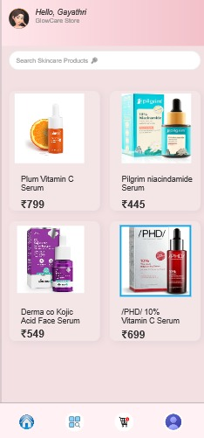

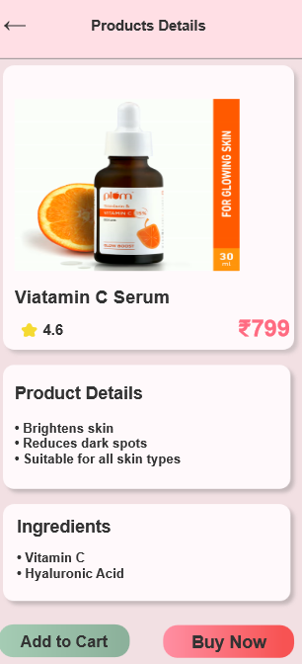

PROTOTYPE LINK:

RESULT:
Thus, the lifecycle stages of UI design were successfully simulated using the RAD model, and an interactive shopping interface was developed using Axure RP.

